CLASS ACTIVITY

- Write a program to store 15 integer values in an ArrayList and remove all duplicate elements without using another collection.

CODE:

import java.util.*;
public class Main {
public static void main(String[] args) {
Scanner sc = new Scanner(System.in);
ArrayList<Integer> list = new ArrayList<>();
System.out.println("Enter 15 integers:");
for (int i = 0; i < 15; i++) {
list.add(sc.nextInt());
}
for (int i = 0; i < list.size(); i++) {
for (int j = i + 1; j < list.size(); j++) {
if (list.get(i).equals(list.get(j))) {
list.remove(j);
j--;
}
}
}
System.out.println("After removing duplicates:");
System.out.println(list);
}
}

OUTPUT:

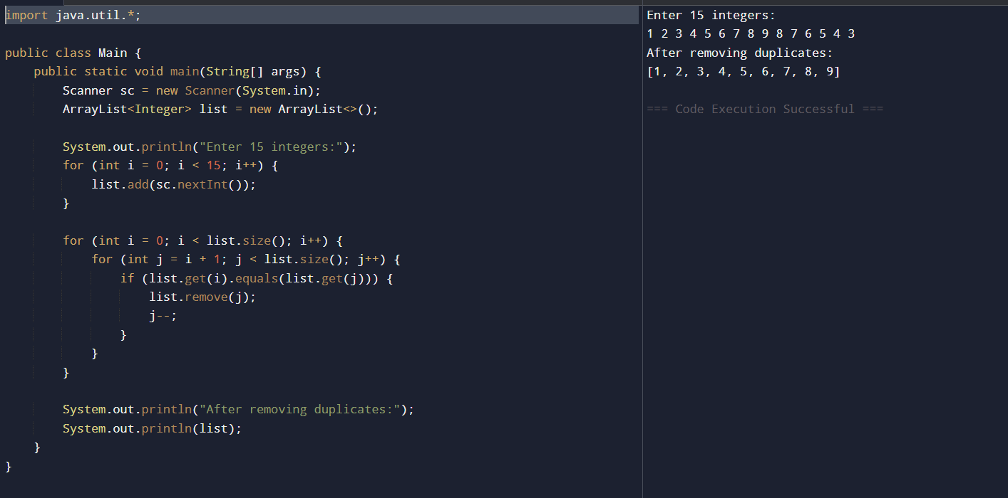
2. Store employee IDs in a LinkedList and display them in both forward and reverse order.
CODE:
import java.util.*;
public class Main {
public static void main(String[] args) {
Scanner sc = new Scanner(System.in);
LinkedList<Integer> list = new LinkedList<>();
System.out.print("Enter number of employees: ");
int n = sc.nextInt();
System.out.println("Enter Employee IDs:");
for (int i = 0; i < n; i++) {
list.add(sc.nextInt());
}
System.out.println("Forward Order:");
for (int id : list) {
System.out.print(id + " ");
}
System.out.println("\nReverse Order:");
ListIterator<Integer> it = list.listIterator(list.size());
while (it.hasPrevious()) {
System.out.print(it.previous() + " ");
}
}
}
OUTPUT:
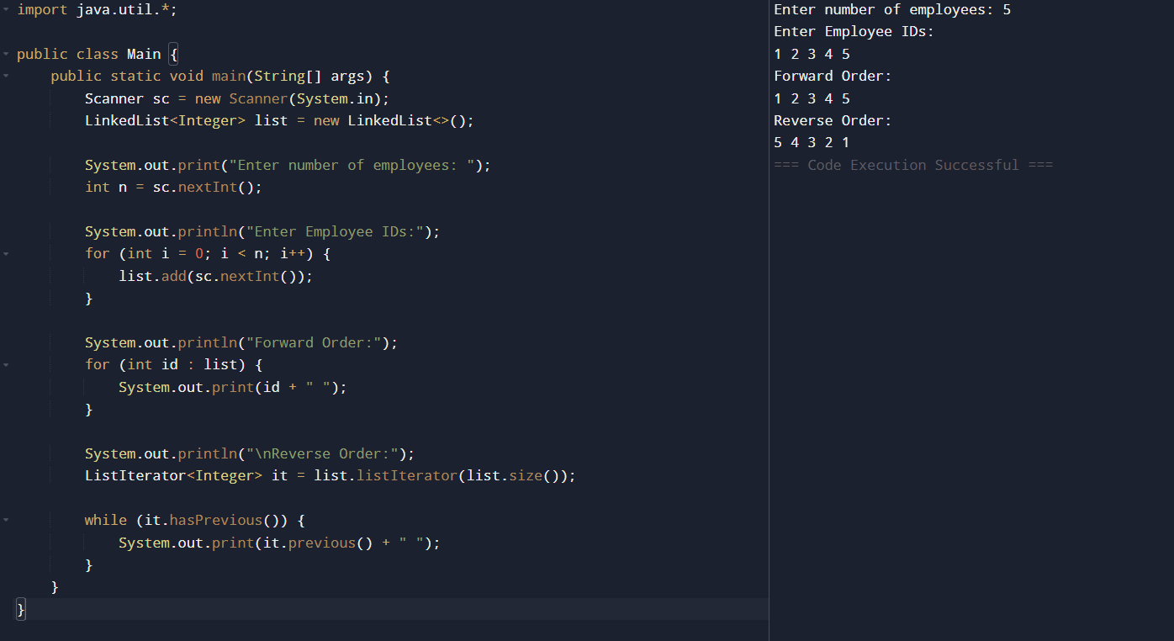

3. Store email IDs entered by the user in a HashSet. Display only unique email IDs and count the total unique entries.
CODE:
import java.util.*;

public class Main {
public static void main(String[] args) {
Scanner sc = new Scanner(System.in);
HashSet<String> emails = new HashSet<>();

System.out.print("Enter number of email IDs: ");
int n = sc.nextInt();
sc.nextLine();

System.out.println("Enter Email IDs:");
for (int i = 0; i < n; i++) {
emails.add(sc.nextLine());
}

System.out.println("Unique Email IDs:");
for (String email : emails) {
System.out.println(email);
}

System.out.println("Total Unique Emails: " + emails.size());
}
}

OUTPUT:

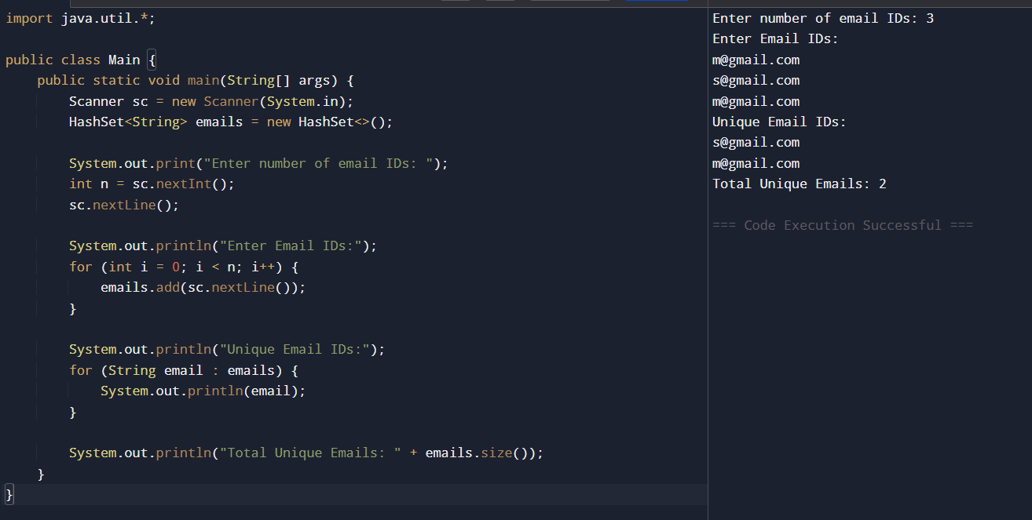

4. Write a Java program to count the frequency of each word in a paragraph using a HashMap.
CODE:
import java.util.*;

public class Main {
public static void main(String[] args) {
Scanner sc = new Scanner(System.in);

System.out.println("Enter a paragraph:");
String para = sc.nextLine();

String words[] = para.split(" ");

HashMap<String, Integer> map = new HashMap<>();

for (String word : words) {
if (map.containsKey(word))
map.put(word, map.get(word) + 1);
else
map.put(word, 1);
}

System.out.println("Word Frequencies:");
for (String key : map.keySet()) {
System.out.println(key + " : " + map.get(key));
}
}
}

OUTPUT:
